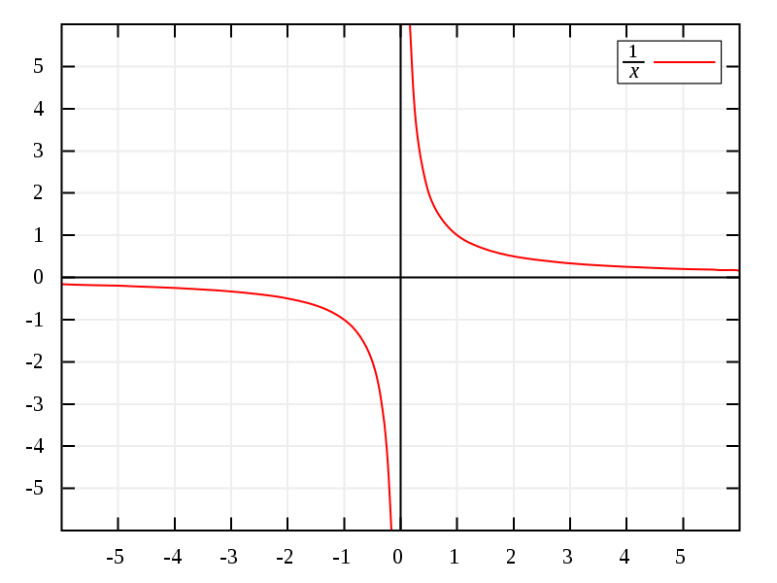**Asymptote** – a line where a function approaches one value as it continues for infinity.

Graph 1

**Horizontal asymptote** – where the $y$ approaches having some **constant value** when $x$ approaches infinity. (Graph 1)

**Vertical asymptote** – where the $x$ approaches having some **constant value** when $y$ approaches infinity. (Graph 1)

# Infinite limits

Some limits **become infinite** when evaluated at certain points.

$\lim_{x→a}{f\left(x\right)}=∞$

“The limit of $f\left(x\right)$ becomes infinity as $x$ approaches $a$.”

“As $x$ approaches $a$, $f\left(x\right)$ increases without bound.”

Note: infinity ($∞$) is **not a real number**, just a way to express the idea of the limit not having a real value.

Limits can also be **negative infinity**.

Wherever the **limit** of a function is **infinity** (or negative infinity) there is a **vertical asymptote**.

Limits can be one-sided with **different values on each side**; vertical asymptotes can be positive infinity at one side and negative infinity at the other side.

Consider Graph 1 and find vertical asymptotes – these are infinite limits.

For all odd integers $n>0$: $\lim_{x→0^{+}}{\frac{1}{x^{n}}}=∞$ or $\lim_{x→0^{-}}\frac{1}{x^{n}}=-∞$.

For all even integers $n>0$: $\lim_{x→0}{\frac{1}{x^{n}}}=∞$.

# Limits at Infinity

Some limits are evaluated where **x approaches infinity** (or negative infinity).

$$\lim_{x→∞}{f\left(x\right)}=L$$

“The limit of $f\left(x\right)$ is $L$ as $x$ approaches infinity.”

“As $x$ increases without bound, the limit of $f\left(x\right)$ is $L$.”

Wherever the **limit** of a function converges as $x$ **approaches** **infinity** (or negative infinity) there is a **horizontal asymptote**.

Infinity can only be approached from the left, and negative infinity can only be approached form the left.

Consider Graph 1 and find horizontal asymptotes – these are limits at infinity.

For all integers $n>0$: $\lim_{x→∞}{\frac{1}{x^{n}}}=0$ and $\lim_{x→-∞}{\frac{1}{x^{n}}}=0$

# Infinite Limits at Infinity

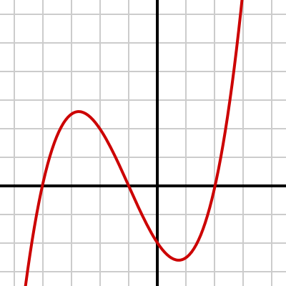Some **limits equal infinity as x approaches infinity** (or negative infinity).

Graph 2

$$\lim_{x→∞}{f\left(x\right)}=∞$$

“The limit of $f\left(x\right)$ is infinity as $x$ approaches infinity.”

“As $x$ increases without bound, the limit of $f\left(x\right)$ increases without bound.”

Infinity can only be approached from the left, and negative infinity can only be approached form the left.

Consider Graph 2 and notice where $y$ approaches infinity as $x$ approaches infinity.

For all odd integers $n>0$: $\lim_{x→∞}{x^{n}}=∞$ and $\lim_{x→-∞}{x^{n}}=-∞$.

For all even integers $n>0$: $\lim_{x→∞}{x^{n}}=∞$ and $\lim_{x→-∞}{x^{n}}=∞$.

# Precise Definitions of Limits

Graph 3

## Infinite Limits

For a function $f$ that is defined on some interval,

If $\lim_{x→a}{f\left(x\right)}=∞$, then,

For every positive number $M$ there is a number $δ>0$ such that,

If $0<|x-a|<δ$, then, $f(x)>M$.

See Graph 3.

## Limit at Infinity

Graph 4

For a function $f$ defined on the interval $(a, ∞)$,

If $\lim_{x→∞}{f\left(x\right)}=L$, then,

For every number $ε>0$, there is a number $N$ such that,

If $x>N$, then, $\left|f\left(x\right)-L\right|<ε$.

See Graph 4.